[13.7] SO(3) is the group of rotations of the unit sphere in 3-space. O(3) extends SO(3) by including reflections. **(A)** Show that SO(3) is a normal subgroup of O(3) and **(B)** show that it is the only proper normal subgroup.

Note. (B) is actually not true. There is one other proper normal subgroup of O(3). In Lemma 9.2 I show that if 1 is the identity element (null rotation) of SO(3) and R is the reflection operation, then **** ={ 1,R } is a normal subgroup of O(3). Then I prove (Theorem 9) that there are no others.

1. Show SO(3) is a normal subgroup of O(3)

**Lemma 1.1:** A subgroup H of a group G is normal iff *g* -1H*g* = H ∀ *g* ∈G

**Proof.** By Penrose’s definition, H is normal iff *g*H = H*g* ∀ *g* ∈G. Left multiplying by *g*-1 yields the lemma.  

We use the symbol ** for the O(3) group operation. In particular, if *f*, *g*∈SO(3), we adopt the convention that  is the composite rotation of *f* followed by *g*. Thus, if *w* = (*x, y, z*), we write *w* () = *w f* ** *g*. This is *the opposite of Penrose’s convention* but, as will be seen, is necessitated by the approach taken to solve (B).

Also note that ()-1 = *g* ‑1 ** *f* ‑1. That is, if *w* is rotated by *f* and then *g*, the inverse operation is to rotate in the reverse directions by *g* and then *f*.

**Definition:** We use **R** to denote the reflection operator on the unit sphere of ℝ3:

(*x*, *y*, *z*) R = (-*x*, -*y*, -*z*).

Note that R is its own inverse: R-1 = R. If *w* is a point then *w* R is its reflection.

We write the composition of a reflection followed by a rotation as R * f*, and a rotation followed by a reflection as *f* ** R. An expression involving an odd number of reflections yields a reflective rotation and an expression involving an even number of reflections yields a non-reflective rotation. In particular, we have the following lemma.

**Lemma 1.2:** If *h* ∈SO(3), then R *h* **R∈SO(3). 

**Definition:** **T** ≡ O(3) – SO(3) is the coset of reflective rotations of the sphere. That is, T = SO(3) ** R, and O(3) is the disjoint union of SO(3) and T:

O(3) = T ∪ SO(3)

The next theorem, Theorem 1, tells us that if *h* ∈SO(3) then the normality operation *g*-1** *h* ** *g* produces another member of SO(3), even if *g* ∈T.

**Theorem 1:** SO(3) is a normal subgroup of O(3)

**Proof:** Clearly SO(3) has an identity, is closed under **, and each non-reflective rotation in SO(3) has an inverse (non-reflective) rotation. So it remains only to show that if *h* ∈SO(3) and *g* ∈O(3) that *g* -1** *h* ** *g* ∈SO(3). Since the composition of 3 non-reflective rotations is a non-reflective rotation, this holds if *g* ∈SO(3). So suppose *g* ∈T. Then ∃ *f*∈SO(3) such that *g* = *f* ** R. Let *h*’ = *f*  ‑1* h* * f* ∈SO(3). So, *g* ‑1** *h* ** *g*  = R ** *f*‑1*h* * f* ** R = R * h*’ ** R∈SO(3) by Lemma 1.2. 

1. Show SO(3) and **** are the only proper normal subgroups of O(3)

It was shown in problem [12.17] that SO(3) is group isomorphic to the (solid) 3‑ball **** of radius *π* in which antipodal points on the surface of **** are identified. The problem was solved by letting elements of **** be written as *f* = *θ* (*a*, *b*, *c*) = (*θ a*, *θ b*, *θ c*), where  *θ* is the (counter-clockwise) angle of rotation, 0 ≤ *θ*  ≤ *π,* and { *t*(*a, b, c* ) : *t* ≥ 0 } is the (positive) axis of rotation.

**Conventions:**

1. **1** will be used to denote the identity element of SO(3). It is the degenerate 0° rotation.
2. An axis of rotation under discussion will be referred to as the **positive axis of rotation**. Its opposite will be called the **negative axis of rotation**.
3. Absolute value **| *f* |** = *θ* will be used to denote the (positive) rotation angle of the rotation *f*.

The representations for points (i.e., rotations) *f* = *θ* (*a*, *b*, *c*) are unique except:

* When *θ*  = 0, there are infinitely many representations for the identity element since any unit vector (*a*, *b*, *c*) can be used.
* When *θ*  = *π*, there are 2 representations for each *π* rotation *f*= *π* (*a, b, c* ) = *π* ( -*a,- b, -c* ) because antipodal points are identified.

As an intermediate step to proving (B), we prove the following theorem, labeled Theorem 8 because there are several steps that are taken to get there.

**Theorem 8:** SO(3) does not contain a proper normal subgroup.

**Outline of Steps to Prove Theorem 8:**

Let H be a proper normal subgroup of SO(3). ∃ 1 ≠ *h* ∈H. Let *θ* = |*h*| > 0 be the rotation angle of *h*. So, . Let S*θ* be the sphere in **** of radius *θ*. S*θ* consists of all rotations of angle *θ* about all axes.

* Let *g* ∈SO(3). We show that *k* = *g* ‑1* h* * g* also has rotation angle *θ*. That is, *k* ∈S*θ*. Thus, starting with *h* ∈H and using only the normality operation

*g* ‑1*h* *g*, we cannot build up to all of SO(3). By using just the normality operation, we can only generate a subset of Sθ.

* We next show that in fact { *g* ‑1 *h g* : *g*∈SO(3) } generates all of S*θ*.
* Next, suppose (a) 0 ≤ *φ* ≤ *π*, (b) *f*1, *g*1 ∈S*θ*, and (c) |*f*1 *g*1| = *φ*. We show

{*f**g* : *f*, *g*∈S*θ* } ⊇ S*φ*. Thus H ⊇ S*φ* .

* Clearly, if (c) holds, the maximum possible size for *φ* is 2*θ* (namely *f f*- for any *f*∈S*θ*). The minimum possible size is 0 (namely, *f f* ‑1). In fact, we will show that {*f  g* : *f*, *g* ∈S*θ* } contains every sphere S*φ* of radius *φ* between 0 ≤ *φ* ≤ 2*θ*, and so every such sphere belongs to H. To generate all of SO(3), we just need to generate larger and larger spheres in H until all of SO(3) is included. That is, starting with S*θ* ⊆ H we can generate spheres of size up to S2*θ* ⊆ H. From S2*θ* we can generate spheres of size up to S4*θ* ⊆ H. Then up to S8*θ*. When 2*nθ* ≥ π, then SO(3) ⊆  ⊆ H and we are done.

The reader who wishes to first get an overview of the rest of the proof of (B) can skip ahead to Theorem 9 and read its overview.

**GA concepts and notation used in this proof**

Non-reflective rotations (henceforth just called “rotations”) are commonly represented by rotation matrices, and the composition  can be computed as a matrix product. Instead, in this proof we learn how to use Geometric Algebra, aka Clifford Algebra, for the computations. In GA, every rotation corresponds to a rotor (described shortly), and geometric product (rather than matrix product) is used to compute the composition of rotations.

Let **{ *e*1, *e*2, *e*3 }** be an orthonormal basis for 3-space. **Rotors** are objects having the form

***r =*** 

where *a*2 + *b*2+ *c*2 = 1, *a*, *b,* c ∈ℝ, and - ∞ ≤ *θ* ≤ ∞.

While *e*1 is a **vector**, *e*1 *e*2 is a **bivector**. *e*1 *e*2 *e*3 is an example of a **trivector**. **Scalars**, vectors, bivectors, trivectors, etc., belong to the class of objects called **multivectors**.

A rotor is the sum of a scalar, , and a bivector (the rest of the expression). This is no stranger than a complex number that is the sum of a real and an imaginary number. The two parts cannot be combined but nonetheless the sum has meaning. In general a multivector can be the sum of multivectors of different **grades** that cannot be combined.

A rotor *r* represents a rotation of angle *θ* about the axis { *t* (*a, b, c*) : *t* ≥ 0 }.

 is called the **rotor angle** and *θ* is the **rotation angle**. As this can be confusing, in this proof only the term “rotation angle” will be used.

The scalar  is referred to as the “**constant term**” of *r* because it does not contain any basis elements. The constant term determines the rotation angle *θ*. That is, if the constant term of a rotor *r* is known to be *K*, then for some *θ*, *K =*****and so *θ*  = 2 Arc**Cos** (*K*).

The magnitude of a rotor is  which is why *a*2 + *b*2+ *c*2 = 1. But even though rotors have magnitude 1, in this proof **| *r* |** will continue to be used to denote the rotation angle *θ* and not 1 (and also not ) in order to be consistent with the definition already given for the magnitude | *f* | of a point (rotation) in ****.

The **geometric product** of 2 multivectors is just the regular polynomial product with a couple of modifications. First, it is non-commutative, so the order of multiplication matters. Second, the basis elements are combined according to the rules



While a rotor can have any angle, **** is defined in this proof as the subset of rotors having (counter-clockwise) rotation angle 0 ≤ *θ*  ≤ *π* under the operation of geometric product. If the rotor *r* ∈**** (i.e., if 0 ≤ *θ*  ≤ *π*), it corresponds to the point (*θ a*, *θ b*, *θ c*) of ****.

The symbol ** will again be used to denote the geometric product, as in . That is, whether *f* and *g* belong to **** or ****,  will represent their composition.

To compute the sometimes algebra-intensive geometric products I wrote a software package in Mathematica that calculates geometric products and also performs other GA operations such as wedge product, multivector inverse, pseudoscalar, etc. The package can be downloaded for free at <https://github.com/matrixbud/Geometric-Algebra>. I have also saved the Mathematica file having the GA calculations used in this proof in the same directory as this file.

Note: Mathematica always displays the bivector *e*3 *e*1 as *e*1 *e*3. Thus, when using Mathematica, the negative of the *b* term must be used, as in

****.

Since the normality operation  involves inverses, this is a good time to provide the GA formula for the inverse of a rotor.

**Theorem 2:** The GA **inverse of the rotor *r*** has the formula

***r -* 1** = ****.

Moreover,

*r -*1 ∈**** if *r*∈ ****.

**Proof.** By computing the geometric product we find that

 and similarly  Thus, *r* *-*1 is the inverse of *r.*  ✔

Another way of seeing that  is that *r* -1 can be written  representing a clockwise rotation about the positive axis that cancels the counter-clockwise rotation of *r*, yielding the identity rotation, 1. ✔

Additionally, since  *r* -1 can also be regarded as a (counter-clockwise) *θ* rotation about the negative axis, showing that *r -*1 ∈**** (since **** is the set of all [counter-clockwise] rotations 0 ≤ *θ*  ≤ *π* about all axes). 

In rotor theory the formula for a rotor *r* to rotate a *point* *w* = x *e*1+ *y e*2 + *z e*3 in 3‑space to some other point *v* is



Effectively, *r* -1 performs half the *θ* rotation () and *r* performs the rest. The reader is encouraged to confirm this for a 90° rotation of the point (1,0,0) in the *xy*-plane. To do this, let , *c* = 1, and *a* = *b* = 0 in the rotor *r*.

To write the expression to rotate a point *w* by *f*  followed by *g*:

* Start with *w*
* Wrap with *f* : 
* Wrap with *g* : 

Thus  in this expression means to rotate first by *f*, then by *g*. This is the reason for the left-right convention adopted on page 1.

Every rotation can be represented by a rotor in ****; i.e., by a rotor of the form where 0 ≤ *θ* ≤ *π*. Every rotation has an additional representation by a rotor with *π* < *θ* < 2*π* that is not in ****. The geometric product of 2 rotors in **** can be outside of ****. To make **** a group under we need to be able to recognize the formulas of rotors not in **** and be able to identify them with equivalent rotors in **.** Thus, we will actually be using ** to represent the geometric product mod ****. However, we will only explicitly write mod **** when it is necessary for the sake of clarity.

**Definition**: We say that 2 rotors *r*1 and *r*2 are **equivalent** if they generate the same rotation.

**Example 1:** Does the geometric product of two  rotations about the *x*‑axis belong to ****?

Answer:The result is a  rotation about the *x*-axis, not in **** since  > *π*.

Theorem 3, below, shows how to recognize a rotor not in **** and how to generate its equivalent rotor in ****.

**Theorem 3:** Let  *π* < *θ* < 2*π*. Then

 and



Also, the constant term of *s* is negative; the constant term of *r* is positive, ‑*s*= *r* ‑1 ∈**,** and *s* is equivalent to -*s*.

**Proof:** *s* ∉**** because  ✔

Since  *r* ∈****. ✔

The constant term of *s* is negative:  < 0 because  < *π*. ✔

The constant term of *r* is positive:  > 0 since 

*r* -1∈**** from Theorem 2. ✔

Claim *r* -1 = - *s* :

Without loss of generality, by a suitable rotation of 3-space, we can assume *s,* and hence *r*, are rotations about the *z*-axis.

  and .

These formulas for *s* and *r* are rotors because they satisfy the rotor definition with *c* = 1 and *a* = *b* = 0. They rotate about the *z*-axis because *e1 e2* rotates the *xy*‑plane.

 ✔

To show *s* is equivalent to *r* -1, we must show that if *w* = (*x*, *y*, *z*)∈ ℝ3 then

 = , i.e., that the rotations of *w* generated by *s* and *r* -1 are the same for every *w*∈ ℝ3 :







**Aside:** Note the change from  to *θ* in the equation above, evidence that *θ* is indeed the rotation angle generated by the expression .

**Example 2:** Find a rotor in **** that is equivalent to the rotor 

Solution: First, by Theorem 3, *s* ∉**** because the constant term is negative. Also by Theorem 3, *s* is equivalent to  and –*s* ∈****.

**Example 3:** If a rotor *s* is a *π* rotation about any axis, then *s*2 should be the identity, a zero rotation. But if, for example,  then  How can that be?

Answer: By Theorem 3, *s2* ∉ **** because the constant term is negative. Also by Theorem 3, *s2* is equivalent to – *s*2 = 1, the identity rotor. The fact that ‑1 = 1 mod **** is important in Theorem 9.

**Aside*:*** If we consider -∞ < *θ* < ∞, then there are infinitely many rotors equivalent to *r* since sine and cosine have period 2*π*. But, for 0 < *θ*  < 2*π* there are only two representations for each rotor, and for 0 < *θ*  < *π* there is only one.

The next theorem is the analog to Penrose’s problem [12.17].

**Theorem 4:** **** is group isomorphic to **** [which is group isomorphic to SO(3)]

**Proof:** Let ***s =* **∈****.

Then 0 ≤ *θ*  ≤ *π* and *a*2 + *b*2+ *c*2 = 1.

*s* can be represented as *s* = (*θ*, *a*, *b*, *c*) ∈****. This representation in **** is unique for 0 ≤ *θ*  ≤ *π* except when *θ* = 0:

* Like ****, when *θ* = 0, there are infinitely many unit points (*a*, *b*, *c*) that can be used to denote the identity rotation.
* Unlike ****, when *θ* = *π* there is only 1 representation for each point *s* because while the antipodal point represents the same rotation, it is not in** **. That is, if *s* = (*π*, *a*, *b*, *c*) ∈****, the antipodal point is (‑*π*, ‑*a*, ‑*b*, ‑*c*), not in **** because *θ* = -*π*.

Define

T: ** ****→ ******: T( *s* ) = *r* where

*s* = (*θ*, *a*, *b*, *c*) and

*r* = *θ* (*a*, *b*, *c*) = (*θ* *a*, *θ* *b*, *θ* *c*).

That is, T: (*θ*, *a*, *b*, *c*) ⟼ *θ* (*a*, *b*, *c*)

T is well-defined:

To show that T is well-defined we must show that (a) T(*s*) ∈**** and (b) if *s* has 2 or more representations, then T assigns the same element of **** in all cases.

(a) Since 0 ≤ *θ*  ≤ *π* and  *r* ∈****.

(b) If *θ*  = 0, then T(0, *a*, *b*, *c*) = 0 (*a*, *b*, *c*) = (0, 0, 0) for any unit vector (*a*, *b*, *c*).

T is obviously 1–1 and onto since T: (*θ*, *a*, *b*, *c*) → *θ* (*a*, *b*, *c*).

T is a homomorphism:

We need to show that T(*s*1  *s*2) = T(*s*1)**T(*s*2)

*s*1  *s*2 is the composition of 2 rotations in ****, and T(*s*1)**T(*s*2) is the composition of 2 rotations in ****. So,

if *s*1  *s*2 = Composition of (*θ*1, *a*1, *b*1, *c*1) & (*θ*2, *a*2, *b*2, *c*2) = (*θ*3, *a*3, *b*3, *c*3)

then T(*s*1) **T(*s*2) = Composition of *θ*1(*a*1, *b*1, *c*1) & *θ*2(*a*2, *b*2, *c*2)

= *θ*3(*a*3, *b*3, *c3*)

So,  

**Steps leading to Theorem 8**

As we move towards Theorem 8, we will be positing a normal group H and an element 1 ≠ *h*1 ∈H. We will expand the singleton set { *h*1 } to a sphere of elements in H using just the normality operation *g* -1** *h*1 *g* where *g* ∈SO(3). Then we will switch to the product operation between elements of the sphere to expand H to all of SO(3).

WLOG,the axes of the unit 3-sphere can be rotated so that *h*1 is a rotation about the *x*-axis. The following lemma provides geometric insight into how to use the normality operation *g* -1* f**g* to generate a rotor whose axis is perpendicular to that of a given rotor. This is accomplished by letting *g* be a 90° rotation about an axis perpendicular to the axis of *f*. For example, if *f* rotates by *θ* about the *x*-axis and *g* is a 90° rotation about the *y*-axis, then *g* -1* f**g* is a rotation by *θ* about the *z*-axis.

**Lemma 5.1:** Let

***h*1** =  (*θ* rotation about positive x-axis)

***h*2** =  (*θ* rotation about positive y-axis), and

***h*3** =  (*θ* rotation about positive z-axis)

If *h*1belongs to a normal group H, then *h*2, *h*3, *h*1-1, *h*2-1, *h*3-1∈H.

**Proof:** Define rotors

 and

.

Then



and



Since H is normal, *h*2, *h*3 ∈H. Since groups are closed under inverses,

*h*1-1, *h*2-1, *h*3-1 ∈ H. 

**Definition**. In ****, let **S*θ*** denote the **sphere of radius *θ***. It consists of all rotations of amount *θ* about all axes in 3‑space. The formula for S*θ* in terms of rotors is



Given *h*, *r* ∈**** it is easy to find *g* ∈**** such that *r* = *h* *g*. Namely, *g* = *h*-1*r*. It is much more difficult to find *g* ∈**** such that *r* = g*-1*  *h*  *g*. In fact, we will prove in Lemma 6.1 that it is not possible at all unless *h* and *r* have the same magnitude. The next lemma (5.2) proves that it is in fact always possible to find such a point *g* if the magnitudes of *h* and *r* are the same, and the lemma provides an explicit formula for *g* (actually 2 formulas, depending on whether *r* has a *x*-component). This lemma (or the alternate proof to Theorem 5, discussed below) is the key step in achieving Theorem 8.

Lemma 5.2 gives formulas for *r* that work but does not explain where they come from. In Appendix 2, I provide what insight I can into how I discovered the formula for rotor *g*23. Discovery of the rotor *g* in part (b) is slightly more transparent because *a* and *b* can be viewed as the sides of a right triangle and hence there is an angle *α* such that *b* = ***Sin*** *α*.

My inability to provide clear insight for the equations in Lemma 5.2 nudged me to develop another proof for Theorem 5 that *is* intuitive and does not depend on either Lemma 5.1 or 5.2. It does use an additional lemma (5.3) that is a generalization of Lemma 5.1. I provide both of the Theorem 5 proofs, though only one is needed in order to proceed. I include the second proof because it is short, clever, geometric and provides an insightful process to find, for a given rotation *r,* a rotation *g* such that *g*-1  *h*  g = *r*. I include the original proof because it is short and Lemma 5.2 includes explicit, compact formulas for generating *r*.

**Lemma 5.2:** Let

*h*1 = ****, *h*3 =****, and

*r* =  ∈ S*θ*,

where *a*2 + *b*2+ *c*2 = 1 and .

1. If *a* ≠ 0 then



*g*2 = 

*g*3 = 

*g*23 = , and

*β*= *Arc* **Cos** () and *γ* = *Arc* **Tan** (*a*, *b* ).

1. If *a* = 0 then



*g* =  and

*α* = *Arc* **Sin** (- *b*).

**Proof:** ArcTan(*a*, *b*) denotes the arc tangent of  taking into account which quadrant the point (*a*, *b*) is in.

1. 







 ✔

Note: The interested reader can find intermediate steps for this and subsequent equations in the accompanying Mathematica file.

(b) Since *a* = 0, then , and





= *r*   ✔

The next theorem summarizes Lemma 5.2. It shows that for a normal subgroup H, if *h* ∈H has rotation angle *θ*, then the sphere S*θ* of radius *θ* lies in H

**Theorem 5:** If H is a normal subgroup of SO(3), 1 ≠ *h* ∈ H and *θ* = | *h*|, then H ⊇ S*θ*.

**Proof:** WLOG we can assume *h* is a *θ* rotation about the *x*-axis. That is,

****.

Let *r* ∈S*θ* . Then for some *a*, *b,* c ∈ℝ such that *a*2 + *b*2 + *c*2 = 1,

*r* =  .

If *a* ≠ 0, by Lemma 5.2a, *r* ∈ H since  and H is normal.

If *a* = 0, by Lemma 5.2b, *r* ∈ H since , H is normal, and *h*3 ∈H (by Lemma 5.1). 

We now present the alternate proof for Theorem 5.

**Outline of Geometric-based Proof of Theorem 5**: As before we begin with *h*1 = *θ* (1, 0, 0) ∈ H and *f* = *θ* (*a*, *b*, *c*) ∈S*θ* . We are done when we show that *f*∈H.

*θ* (0, 0, 1)

*θ* (0, 0, 1)

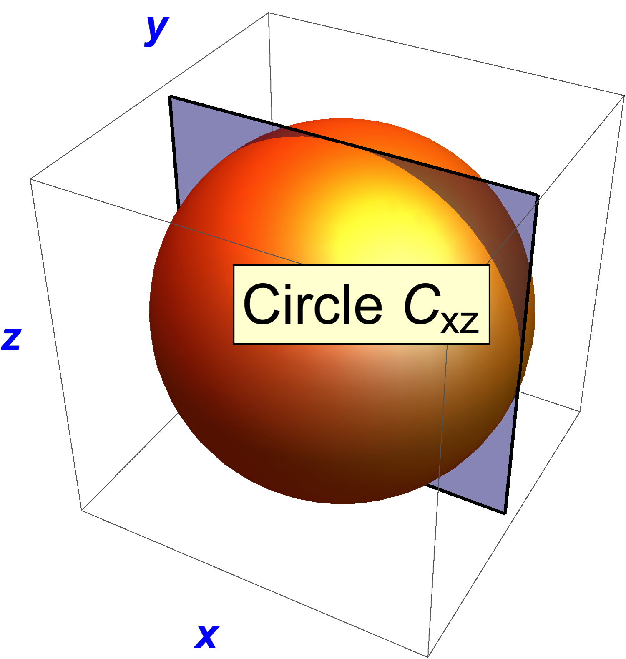 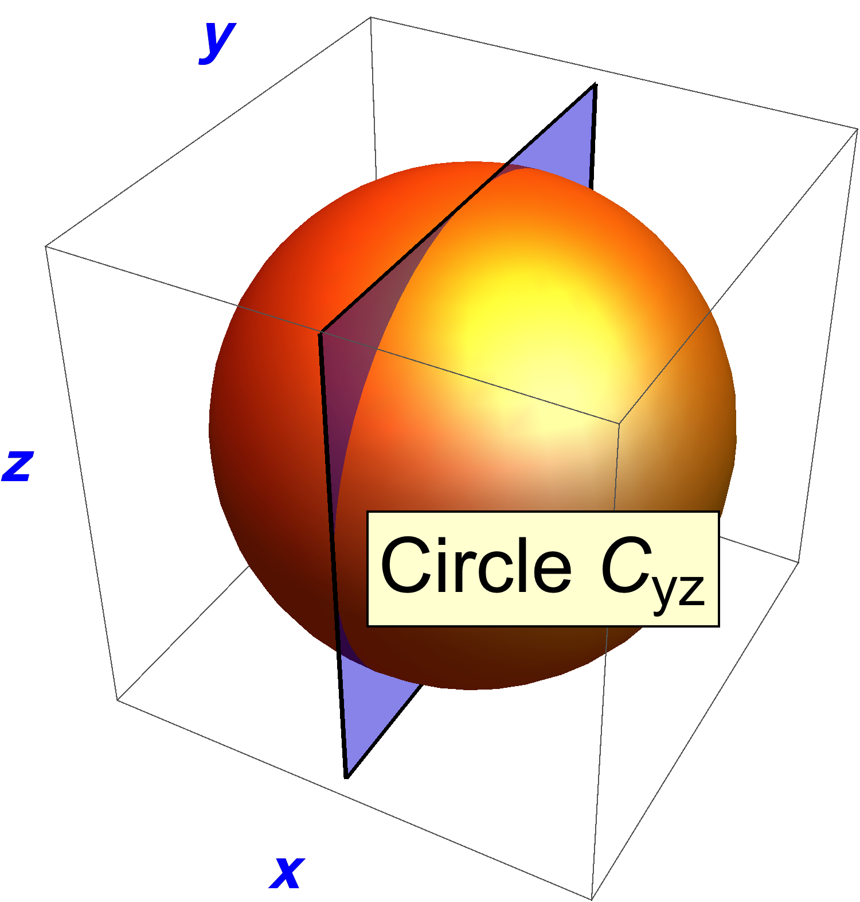 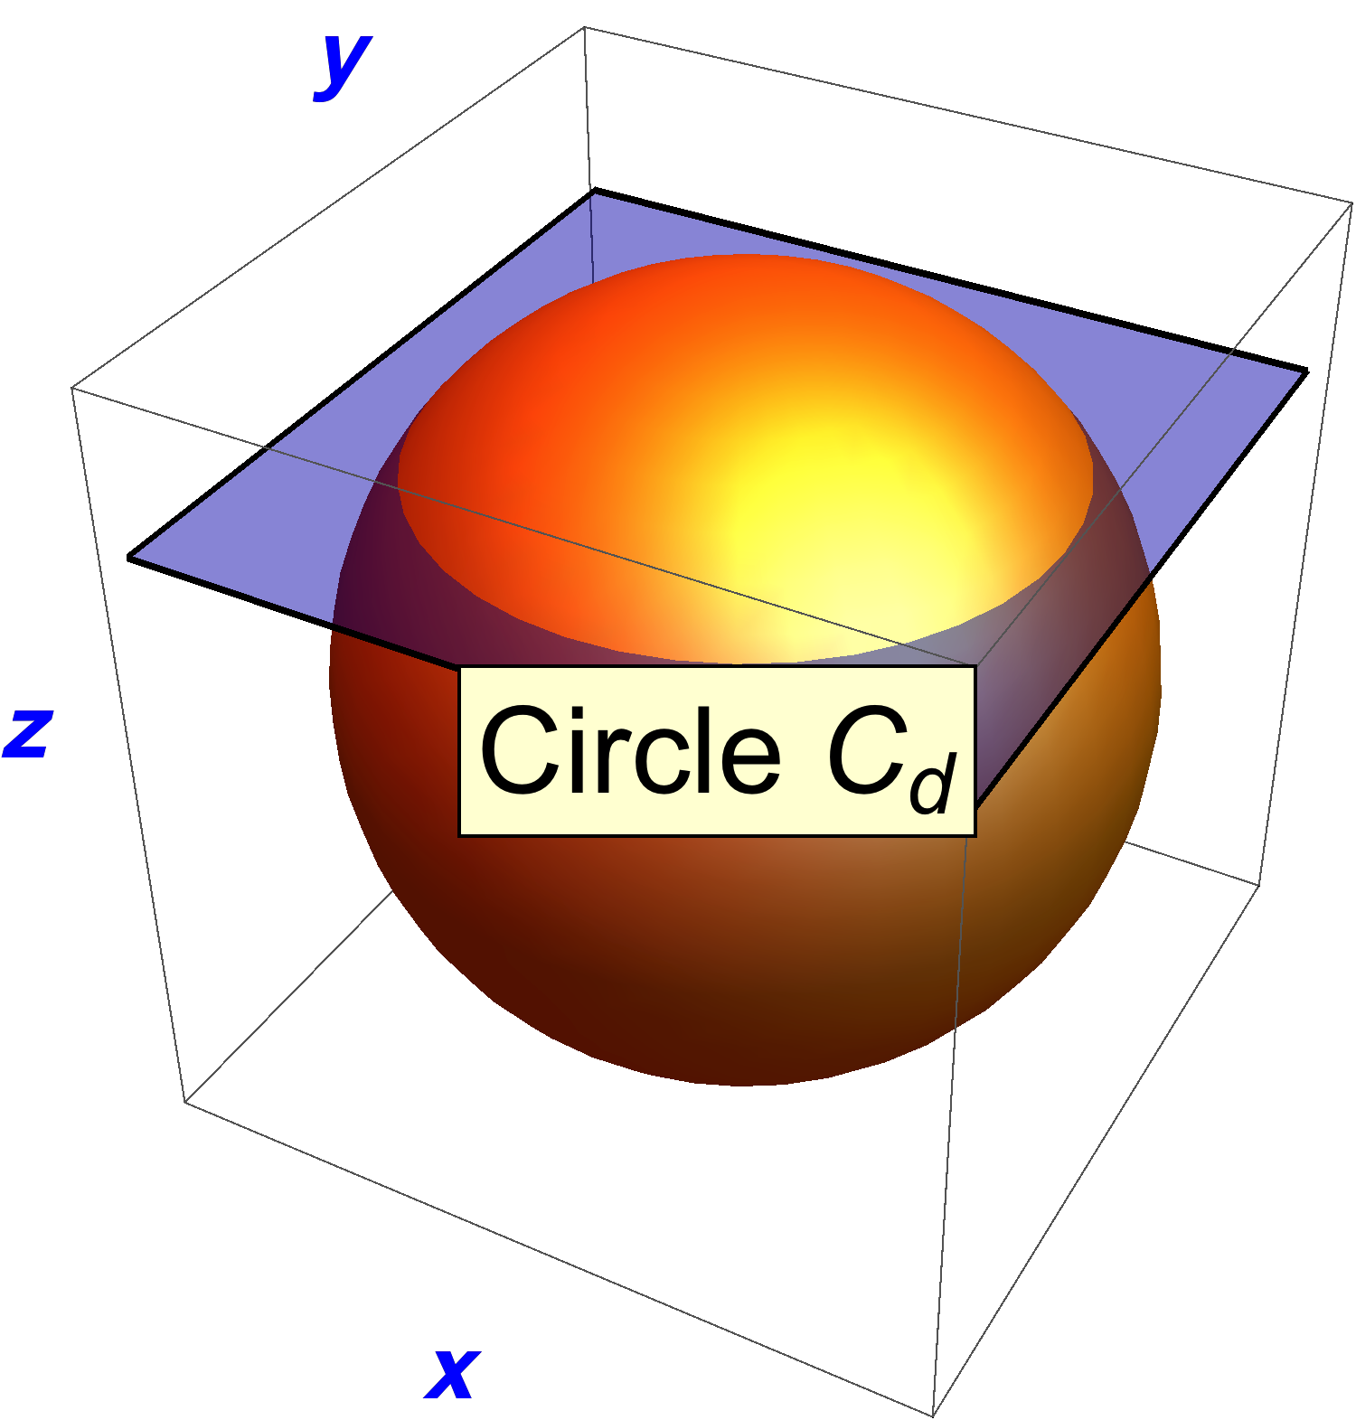

S*θ*

S*θ*

S*θ*

In the figure above, circle C*xz* of radius *θ* about the origin is formed by slicing the sphere S*θ* with the *xz*‑plane of ****. Circle C*yz* is similarly formed by slicing S*θ* with the *yz*‑plane. Lemma 5.3 will prove that these circles lie in H.

The third circle in the figure is formed by taking a horizontal slice of S*θ* at height *z* = *cθ*, where 0 ≤ *c* ≤ 1. This generates a circle C*d* of radius  that contains *f.* Thus, points on C*d* have coordinates *θ* (*d* **Cos** *φ***,***d***Sin***φ,* *c*) where *φ* is the counter-clockwise angle from the *x*-axis of an *xy*-plane raised to height *c*. We show that the formula for *φ* is 

Next we show that if *gφ* = *φ*(0, 0, 1) and *h* = *θ* (*d*, 0, *c*), then *gφ*‑1  *h*  *gφ* ∈ C*d* and, in fact, {*gφ*‑1 *h* *gφ* : *-π ≤ φ ≤ π*  } generates C*d*. In particular, it generates *f*, proving *f* ∈H since *h* ∈C*xz* ⊆ H

**Geometric Insight:** We have again used rotations (specifically, *gφ* and *h*) about axes perpendicular to the axis of *f* to generate *f* via the normality operation. This time, however, *gφ* is not required to have a 90° rotation angle but, rather, as *φ* varies from *-π* to *π*, the normality operation*gφ*‑1 *h* *gφ* traces out the Circle C*d*.

**Lemma 5.3:** If *h*1 = (*θ*, 0, 0) ∈****belongs to a normal group H, then H contains C*xy*, C*yz*, and C*xz*, the circles of radius *θ* centered at the origin in the *xy*-, *yz*-, and *xz*-planes of ****, respectively.

**Proof:** The lemma is just a slight generalization of Lemma 5.1 Recall ****. Similarly to Lemma 5.1, let  and where 0 ≤ φ ≤  Also set . Then .

Recall from page 2 of this proof that the axis of rotation of  is { *t* (**Cos***φ*, **Sin***φ*, 0) : t ≥ 0 }. Thus rotor  is represented in **** as the point *θ* (**Cos***φ*, **Sin***φ*, 0)**.**  As *φ* varies from -*π* to *π*, these points sweep out the circle C*xy*. Similarly, the set of points  forms the circle C*xz* and  forms the circle C*yz*, where ****. These circles are contained in H because H is normal and, in the case of the 3rd circle, also because *h*2 ∈H (because *h*2 ∈Cxz ⊆ H).

*φ*

*a* = *d* **Cos** *φ*

*b* = *d* **Sin** *φ*

*d*

**Theorem 5 Proof #2:** Let H be a non-trivial normal subgroup of SO(3). WLOG let (0, 0, 0) ≠ *h*1 = (*θ*, 0, 0) ∈H be the element of **** representing a *θ* rotation about the *x*-axis. Let *f* = *θ* (*a*, *b*, *c*) ∈S*θ* . It suffices to show that *f*∈ H.

If *a* = 0, then *f* ∈C*yz* ⊆ H by Lemma 5.3.

So we can assume *a* ≠ 0.

Let C*d* be the circle formed by taking a horizontal slice of S*θ* at height *z* = *c θ*.

The radius of C*d* is .

We wish to represent *f* also as *f* = *θ* (*d* **Cos** *φ***,***d* **Sin***φ,* *c*) since it is a point on the circle C*d*.That is, we desire an angle *φ* such that *a* = *d* **Cos** *φ* and *b* = **Sin** *φ*. To do this, we define *φ* = **ArcTan** (*a*, *b*), which is **ArcTan**  but adjusts *φ* for the quadrant of (*a*, *b*). *φ* is well-defined because *a* ≠ 0. In order to make **Sin** *φ* =  and **Cos** *φ* =  well-defined, we also must have *d* ≠ 0. But, if *d* = 0 then *f*  = *θ* (0**,**0, ±1) ∈C*yz* ⊆ H (see Circle C*yz* figure), and we are done. So we can assume *d* ≠ 0.

Let

 = *φ* (0, 0, 1)

be the rotation of angle *φ* about the *z‑*axis.

Let

 = *θ* (*d*, 0, *c*),

a point of the circleC*xz*. *h* ∈ H by Lemma 5.3.

Finally,





Therefore *f* ∈H and S*~~θ~~* ⊆ H. 

The next lemma shows that for any *g* ∈SO(3), the normality operation  results in a rotation having the same rotation angle as *h*. Thus, for a given *h* ∈SO(3),  cannot generate all of SO(3). The prior Lemma 5.2 (as well as the alternate proof of Theorem 5) tells us that it at least generates *all* of S*θ*.

**Lemma 6.1:** Let , *h* ∈ S*θ*, and *g* ∈SO(3). Then  ∈S*θ*.

**Proof:** WLOG  Since 2 vectors determine a plane, WLOG we can also assume that *g* lies in the *xy*-plane. That is, if the magnitude of *g* is  then  where *a*2 + *b*2 = 1. Then 





Since the constant term of  is **,** ∈S*θ*.

Now we switch tactics, using the product operation rather than the normality operation to generate additional elements of H. We will show that geometric products of pairs of elements in S*θ* generate every sphere S*ω* and, hence, all of SO(3).

The next theorem starts the process. It shows the ability to generate one sphere in **** from another by taking products of pairs of elements from the first sphere.

**Theorem 6:** Let *k*1, *k*2 ∈ S*θ* for some , and let *ω* = ||. Then S*ω* can be generated from geometric products of pairs of elements from S*θ*.

**Proof.** The theorem is trivially true if *ω* = 0, so assume *ω* > 0. Let *r* ∈S*ω*. The claim is that we can find *f*1, *f*2 ∈S*θ* such that *.* WLOG let  be the *ω* rotation about the positive *x*-axis. That is ****.

Since *r* ∈ S*ω*, ∃ *a*, *b,* c ∈ℝ such that  where *a*2 + *b*2 + *c*2 = 1.

Lemma 5.2 yields that either (a)  or (b) , where *h*3 ∈ S*ω* is the ** rotation about the *z*-axis and *g*23 and *g* are as defined in the lemma (using *ω* rather than *θ*).

(a) Define  and . By Lemma 6.1, *f*1, *f*2∈ S*θ*.

Thus,

 ✔

(b) As was shown in Lemma 5.1, *h*3 can be obtained from *h*1 by a normality operation using the 90° rotation . The rotation formula is . Apply the same 90° rotation to *k*1 and *k*2 :

 and .

By Lemma 6.1, *k*3, *k*4 ∈S*θ* and

.

Define  and . By Lemma 6.1, *f*1, *f*2∈S*θ*. Thus

 ■

The next theorem and its corollary show how to generate all of SO(3) from geometric products of pairs of elements of S*θ*.

**Theorem 7:** Suppose  and 0 < *ω* ≤ *π*. Then there is a pair of elements in S*θ* whose geometric product lies in S*ω* .

**Proof:** Let *h*1 be the rotor in S*θ* that rotates by *θ* about the *x*-axis:



*h*1 is the first desired element of S*θ*. We will find a second rotor, *h* ∈ S*θ* , such that *h* *h*1  ∈ S*ω* . To define *h*, we need *a*, *b*, *c* ∈ ℝ such that

*a*2 + *b*2 + *c*2 = 1,

***h*** = ****, and

.

Recall that  ⇔ Constant term of  = .

By performing the geometric product calculation we find that









The constant term of rotor  = .

Setting  and solving for the coefficient *a* yields

***a*** = 

This is well defined except when  which occurs only when

**= 0 mod 2*π*. Since 0 is outside the domain  of *θ*, the definition of *a* is well defined. “*b*” and “*c*” can be any numbers so long as *a*2+ *b*2+ *c*2 = 1. In fact it is convenient to set *b* = 0 and have .

Finally, we must show that *a*, *b,* c ∈ℝ which will conclude the proof of the theorem. To do this we must show that *a*2 ≤ 1.

Since 0 < ω ≤ *π*,

0 <  ≤ ,





 (iv)

Since 





 (v)





 (vi)

Thus,



That is, | *a* | ≤ 1. 

**Corollary 7.1:** Suppose , 0 < *ω* ≤ *π*, and S*θ* ⊆ H, where H is a group, not necessarily normal. Then S*ω* is generated by geometric products of pairs of elements from S*θ* , and so S*ω* ⊆ H.

**Proof:** By Theorem 7, ∃ *k*1, *k*2 ∈ S*θ* ⊆ H such that  By Theorem 6, S*ω* = 

**Theorem 8:** SO(3) contains no proper normal subgroup.

**Proof:** Let H be a non-trivial normal subgroup of SO(3). H contains a non-identity element 1 ≠ *h0* ∈H where *h0* is a rotation by some angle *ϕ* ≤ *π*  about some axis.

Since *h0*≠ 1, *ϕ* > 0.

Since *ϕ* > 0, there is a positive integer *n* such that .

Define *h* =  and *θ* = *n ϕ*.

*h* Is a rotation of angle *θ*, and . Thus *h* ≠ 1.

Since 1 ≠ *h*, by Theorem 5, S*θ* ⊆ H.

We wish to show that H = SO(3). It suffices to show that H contains every sphere S*ω* in ****. For *ω* = 0, S*ω* ⊆ H since 1 ∈ H. So let 0 < *ω*  ≤ *π* be an arbitrary rotation angle. By Corollary 7.1, S*ω* ⊆ H. 

**Geometric Algebra Treatment of Reflections and Reflective Rotations:**

Recall that O(3) is the disjoint union **O(3) = SO(3) ∪ T** of the non-reflective and reflective rotations, respectively. In GA terminology, we can write this as **O(3) =**** ∪ ** . We have already defined ****. Its elements are rotors, multivectors having the form

*f* = ****,

where  and 0 ≤ *θ*  ≤ *π*.

We wish to define ****. That is, we wish to describe a reflective rotation, *h*, in GA terms. We cannot represent *h* as a rotor because all rotors represent non-reflective rotations. Instead, we seek to represent *h* as a 3‑dimensional multivector. Moreover, just as *f* ‑1 *v* *f* (non-reflectively) rotates the vector *v* into some vector *w,* we require the multivector *h to* have the property that *h* ‑1 *v* *h* reflectively rotates *v* into -*w*. That is, we require

- *w* = *h*‑1 *v* *h* (vii)

Because *h* = *f* R, a rotation followed by a reflection, we also wish to find a multivector representation for the reflection operator R.

We quickly discover that the expression for the multivector R to reflect a vector *w* into –*w* must be -*w* = R *w* R. To see this, let

* *v* ∈ℝ3 : a vector in ℝ3
* -*v* ∈ℝ3 : the vector obtained by reflecting *v*
* *f* ∈**** : a rotation
* *w* = *f*‑1  *v* *f* ∈ℝ3 : the vector obtained by rotating *v* by *f*
* -*w* ∈ℝ3 : the vector obtained by reflecting *w*
* *h* = *f* R ∈**** : the reflective rotation generated by *f*

Since a reflection followed by a reflection is the identity, R is its own inverse, R = R‑1. So,

- *w*  *h*‑1 *v* *h* = (*f* R)-1 *v* (*f*  R) = (R-1 *f* -1)  *v* (*f*  R)

= R (*f* -1  *v*  *f*)  R

= R *w* R (viii)

Defining R =  satisfies equation (viii). *i* is a scalar, and the scalar *i* is a multivector, so this satisfies our goal of defining R as a multivector. In Appendix 1 it is shown that while there are other multivector expressions for R that satisfy equation (viii), all such expressions involve imaginary terms. In Definition (1), below, we define R = *i*, the simplest such expression.

Since *i* is a scalar, it commutes with the geometric product operator:

*f* *g* *i*  = *i* (*f*  *g*) =  (*i* *f* ) *g*  = *f*  (*i**g*) for all multivectors *f* and *g*.

**Definition:** The **Reflection Operator** is actually 3 different operators, depending on its domain. The original operator R with domain ℝ3 induces operators on **** and ****. Let , *v* ∈ℝ3, *f* ∈****, and *h* ∈****. Define

1. **R**  : ℝ3 → ℝ3 : R(*v*) = R‑1 *v* R = *i* *v*  *i***= - *v***; i.e., **R = *i* = R**-1.
2. **RS** :  ** **→ **** :  RS(*f*) = *f*   RS = *f*   *i*  =  ***i******f***; i.e., **RS = *i* =** **RS-1**.
3. **RT** :  **** → **** : RT(*h*) = *h*  RT = *h*  (- *i* ) = **- *i h***; i.e., **RT = - *i* = RT**.

These definitions require clarification. We begin by observing we are now able to identify the multivector representation of a reflective rotation:

1. 

where *f* ∈****,  and 0 ≤ *θ*  ≤ *π*.

Lemma 9.1 provides the equation for the inverse of a reflective rotation.

**Lemma 9.1:** Let *h* = *f*  *i* ∈****, where *f* ∈****. Then *h* -1 = *f* -1 *i*.

**Proof:** Let *g* = *f* -1 *i*. By definition (2), *g* ∈**** since *f* -1∈****. Because the expression for the geometric product of 2 members of **** involves 2 reflections, *g*  *h* ∈****. Thus,

*g* *h* = (*f* -1 *i* )  (*f*  *i* ) = *i* *2* (*f* -1 *f* ) = -1.

Recall from Theorem 3 that -1 ∉**** but -1 ≈ 1 ∈****. Therefore *g*  *h* = 1 mod ****. Similarly, *h* *g* = 1, and we have that *h* -1 = *g* = *f* -1 *i*. 

Lemma 9.1 is somewhat surprising because one might expect that *h* ‑1 = *i* ‑1  *f*‑1 = **–** *f*-1 *i*. The subtlety here is that when *i* ∈ℂ then *i* ‑1 = - *i*, but *i* ‑1 = *i* mod ** **when *i* is a reflective rotation[1]. This is similar to (and follows from) 1 ≠ -1 when 1 ∈ℝ but 1 = -1 mod **** (according to Theorem 3) when 1 is a rotation.

In the reflection operator definition, what does it mean when we say that R *induces* R****? Observe that both *w* R and *f*  R appear in equation (viii). In *w* R, R is acting on a vector, but in *f*  R, R is acting on a rotation. So the R in *f*  R becomes what I am calling the induced reflection R****. The domain of the reflection operator has changed but the multivector expression hasn’t changed, so RS = R = *i*, which is Definition (2).

Why is RT  = - *i* (rather than just *i*) in Definition (3)? Because 1 = RS  RT = *i* RT.

**Outline of Proof of Theorem 9:**

Observe that what was called the reflection operation “R” in the 2nd paragraph of page 1 is now defined to simply be “*i*". That is, *i* = RS ∈T. Using this notation, we have that the subgroup **** = {1, *i* }.

Let H be a proper normal subgroup of O(3) such that H ≠ SO(3) and H ≠ ****. From Theorem 8, ∃ *i* ≠ *h* ∈ H ∩ T. Then *h*2∈SO(3) ∩ H. If 1 ≠ *h*2, by Theorem 8, SO(3) ⊆ H. Also, ∃*f*∈SO(3) such that *h* = *f*  RS = *i* *f*. To see that T ⊆ H, let *t* ∈T. ∃*f*1 ∈SO(3) such that *t* = *f*1 RS = *i* *f*1. Let *f*2 = *f*1  *f*‑ 1 ∈SO(3). Then *f*1 = *f*2  *f*. So,

*t* = *i* *f*1 = *i* (*f*2  *f* ) = *f*2  (*i* *f* ) = *f*2   *h*.

*t*∈H since *f*2 ∈SO(3) ⊂ H. Thus T ⊆ H. Since, also, SO(3) ⊆ H, then H = O(3).

Unfortunately, *h*2 does equal 1 when either *h* = *i* (ruled out) or *h* is the reflection of any *π* rotation (allowed). Even so, everything in the prior paragraph still holds except we will not have proved that SO(3) ⊂ H. To prove this, we will generate *h*1 ∈H ∩ T such that 1 ≠ *h*  *h*1 ∈SO(3). Then we will again have, by Theorem 8, that SO(3) ⊆ H.

Notice that *h* = *f*  RS ⇔ *h* = *i f* ⇔ *f* = - i *h* ⇔ *f* = *h* RT. That is,

*h* = *f*  RS ⇔ *f* = *h* RT (ix)

**Lemma 9.2:** **** = {1, *i* } is a normal subgroup of O(3).

**Proof:** *g*‑1 1  *g* = 1 and *g*‑1 *i*  *g* = *i* for every *g* ∈O(3). 

**Theorem 9:** SO(3) and **** are the only proper normal subgroups of O(3).

**Proof:** To help keep track of variables, we will use *s*, *s*0, *s*1, *s*2, *s*3, and *s*4 for elements of SO(3) and *t*, *t*0, *t*1, and *t*2 for elements of T.

Suppose H is a non-trivial normal subgroup of O(3) and H ≠ SO(3) and H ≠ ****.

Claim: There is an element ***t*1** ∈ H ∩ T such that *t*1 ≠ *i*:

By Theorem 8, ∃ *t0* ∈ H ∩ T. If *t*0 ≠ *i*, the claim is true. If *t*0 = *i*, since H ≠ , H contains another element. If that element is in T, the claim is true. If the other element is *s*0 ∈ SO(3), we can assume *s*0 ≠ 1 since H ≠ . Set *t*1 = *s*0 *i*. Then *t*1 ∈ H ∩ Tand *t*1 ≠ *i*.

As an intermediate step we wish to find an element *t*2 ∈H ∩ T such that *t*1 *t*2 ≠ 1. Set

***s*1** ≡ *t*1 RT = - i *t*1∈SO(3).

WLOG, we can assume *s*1 is a rotation about the ***x*-axis**. Thus,



By (ix),

***t*1** = *s*1 RS = i *s*1 = 

and



Let  ***θ*** = | *s*1 |. *θ* ≠ 0 because *t*1 ≠ *i* and, consequently, *s*1 ≠ 1. Define

***g*2** = 

a 90° rotation about the ***y-axi****s*. *g*2 ∈SO(3) since it is a rotation. Hence,

***s*2** ≡ .

*s*2 ∈SO(3) is the rotation of angle *θ* about the negative ***z*-axis**. Define

***t*2** ≡ 

So and





Notice that the constant term of *t*­1 *t*2 < 0. So, by Theorem 3, we replace the expression for *t*­1 *t*2 by its negative:



Since θ ≠ 0, *t*­1 *t*2 ≠ 1. This concludes the intermediate step.

We next wish to show that H ⊃ SO(3). First, we observe that



We define

***s*3**

1 ≠ *s*3∈H because   *s*3∈SO(3) because  So,

1 ≠ *s*3 ∈H ∩ SO(3).

H ∩ SO(3) is thus a non-trivial normal subgroup of SO(3), so by Theorem 8

H ∩ SO(3) = SO(3).

Thus,

H ⊃ SO(3).

Finally, we are in a position to show as well that H ⊃ T, implying that H = O(3) since H ⊃ SO(3) ∪ T = O(3). Let ***t* ∈T** be any element of T. This proof is finished if we can show *t* ∈H. Let

***s*** ≡ - i *t* = *t*  RT ∈SO(3).

∃ *x*, *y*, and *z* where *x*2 + *y*2 + *z*2 = 1 and ω satisfying 0 ≤ ω ≤ *π* such that



By (ix),



Define

***s4*** ≡ *s*1-1 *s* ∈SO(3) ⊂ H.

*s4* is the rotation whose geometric product with *s*1 equals *s* :

*s* = (*s*1 *s*1-1) *s* = *s*1 (*s*1-1 *s*) = *s*1 *s4*.

Therefore *s4* is also the rotation whose geometric product with *t*1 equals *t* :

*t* = *s*  *i* = (*s*1 *s4*)  *i* = (*s*1 *i*)  *s4* = *t*1 *s4*

So, *t* ∈H since *t*1, *s4* ∈H, and that completes the proof the theorem and part (B).

■

**APPENDIX 1:** **GA expressions for defining the reflection operator** **R:**ℝ3 → ℝ3

Let *w* be a vector in ℝ3. Without loss of generality,

*w* = *e*1

We need to solve for the coefficients in the GA multivector expression for R:

R = *c*0 + *c*1 *e*1+ *c*2 *e*2 + *c*3 *e*3 + *c*12 *e*1 *e*2+ *c*23 *e*2 *e*3 + *c*13 *e*1 *e*3 + *c*123 *e*1 *e*2 *e*3

From equation (viii) R must satisfy

R *w*  R = - *w =* - *e*1.

By symmetry,

*c*1 = *c*2 = *c*3 and *c*12 = *c*23 = *c*13.

Thus,

R = *c*0 + *c*1 *e*1+ *c*1 *e*2 + *c*1 *e*3 + *c*12 *e*1 *e*2+ *c*12 *e*2 *e*3 + *c*12 *e*1 *e*3 + *c*123 *e*1 *e*2 *e*3.

Expanding  yields

 = - *w* = 0 –  *e*1+ 0 *e*2 + 0 *e*3,

where



,

,

and

.

This leads to 4 equations in the 4 unknowns *c*0, *c*1, *c*12, *c*123 :



Adding equations (3) and (4) yields



Equation (1) then becomes

.

 is not possible because, along with , it transforms (2) into

.

Thus



which implies that

.

So

R = *c*0 + *c*123 *e*1 *e*2 *e*3

and equation (2) becomes

 .

From this it is clear that if *c*0 is real, then *c*123is imaginary. This proves the claim that every multivector representation for R involves an imaginary term.

I list below the four simplest expressions for R:

R = ±*i*

R = ±*i* *e*1 *e*2 *e*3

R = 

R = 

For the record, if instead of starting with *w* = *e*1 we use , the resulting equations lead to the same solution set.

**APPENDIX 2: The 2 insights that suggested how to define the rotor g23 in Lemma 5.2.**

The hardest part of this proof was to invent the rotor *g*23. I couldn’t solve a certain system of 4 non-linear simultaneous equations that would have provided it, but I was able to guess a solution after examining lots of rotations.

The **1st insight**, gained during Lemma 5.1, is that a rotor, say *h*3, about the *z*‑axis, is obtained by *g*2-1*h*1*g2* where *g*2 is a rotor about the *y*-axis with a 90° rotation angle and *h*1 is a rotor about the *x*-axis having the same angle of rotation, *θ, as h*2. Loosely speaking, I learned that a 90° rotation *g*2 yields a rotation about an axis 90° away from *h*1.

**2nd Insight** comes from discovering that reducing the *g*2 angle of rotation to 45° generates a rotation about the 45° diagonal between the x-axis and *z*-axis (i.e., about an axis 45° away from *h*1), seen below:

Let

*g*2 = 

Then



To generate a 45° diagonal axis not in the *xy*-, *yz*-, or *zx*-planes, I made a guess that it requires products of rotors like *g*2 and *g*3 where *g*2 generates a skew axis between the *z* and *x-*axes, and then *g*3 generates an out-of-*zx-*plane skew axis towards the *y*-axis.

Armed with the guess *g*23 = *g*2*g*3, for a given angle *ψ*:

* I assigned *g*2 and *g*3 rotor angles *β* and *γ*, respectively,
* Performed the *g*23-1*h**g*23 GA multiplication with Mathematica, and
* Solved for a constant term equal to .

This yielded the *Arc***Cos** and *Arc***Tan** values used in Lemma 5.2. The proof in Lemma 5.2 is just the confirmation multiplication that the solution found is correct.

1. *i* -1= R-1 = *i*.